WD-Activity-Based-Learning
Case-Study-1
Experiment 1:portfolio
1. Introduction
A Personal Profile Website is a simple webpage that introduces a person and provides information about their education, interests, hobbies, and goals. It is developed using HTML and CSS.
HTML is used to create the structure of the webpage, while CSS is used to design and style it. This project displays a personal profile with a heading, profile picture, introduction, hobbies list, and career goal.
2. Explanation
The Personal Profile Website contains the following elements:
- Heading: Displays the title "My Personal Profile."
- Profile Image: Displays the user's profile picture.
- Introduction: Provides information about the student and their interests.
- Hobbies: Lists activities such as playing cricket, listening to music, and learning programming.
- My Goal: Describes the student's future career ambition.
- CSS Styling: Adds background colors, font styles, rounded corners, spacing, and shadows to make the webpage attractive.
Technologies Used:
- HTML – To create the webpage structure.
- CSS – To style and design the webpage.
3. HTML Code
Create a file named index.html.
<!DOCTYPE html>
<html lang="en">
<head>
<meta charset="UTF-8">
<meta name="viewport" content="width=device-width, initial-scale=1.0">
<title>My Personal Profile</title>
<link rel="stylesheet" href="workshop.css">
</head>
<body>

<div class="profile-container">

<h1>My Personal Profile</h1>

<img src="profile.jpg"
alt="My Profile Picture"
class="profile-image">

<h2>Hello, I'm Sushupthi!</h2>

<p>
I am a first-year B.Tech Computer Science student.
I am interested in Artificial Intelligence, programming,
and learning new technologies.
</p>

<h3>My Hobbies</h3>

<ul>
<li>Playing Cricket</li>
<li>Listening to Music</li>
<li>Learning Programming</li>
<li>Exploring Artificial Intelligence</li>
</ul>

<h3>My Goal</h3>

<p>
My goal is to become a skilled software engineer
and develop useful applications using technology.
</p>

</div>

</body>
</html>
4. CSS Code
Create another file named workshop.css.
/* Style the entire webpage */
body {
font-family: Arial, sans-serif;
background-color: #eaf2f8;
margin: 0;
padding: 20px;
}

/* Profile container */
.profile-container {
max-width: 500px;
margin: 30px auto;
padding: 25px;
background-color: white;
text-align: center;
border-radius: 15px;
box-shadow: 0 4px 10px rgba(0, 0, 0, 0.2);
}

/* Main heading */
h1 {
color: #2c3e50;
}

/* Subheadings */
h2 {
color: #2980b9;
}

h3 {
color: #16a085;
}

/* Profile image */
.profile-image {
width: 150px;
height: 150px;
border-radius: 50%;
object-fit: cover;
border: 3px solid #2980b9;
}

/* Paragraphs */
p {
color: #444;
font-size: 16px;
line-height: 1.6;
}

/* Hobbies list */
ul {
display: inline-block;
text-align: left;
color: #333;
line-height: 1.8;
}
Important: Save both files in the same folder. Place your photo in that folder and name it profile.jpg. Then open index.html in a web browser to view your profile website.
5.Output
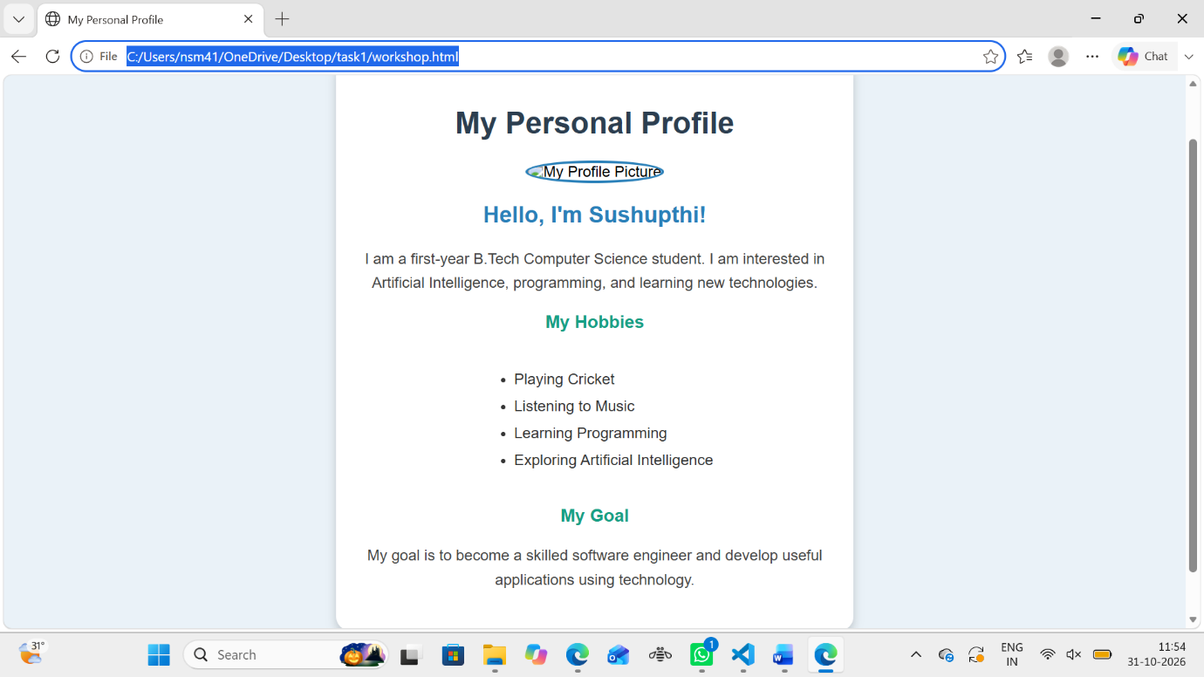
6. Conclusion
The Personal Profile Website was created successfully using HTML and CSS. HTML provides the structure, while CSS improves the appearance of the webpage. This project helps beginners understand basic web development concepts, including headings, paragraphs, images, lists, colors, spacing, and layouts. It is a useful first step toward learning website design and development.

Case Study -2
Experiment :My College Website
1. Introduction
A College Information and Admissions Website is designed to provide information about a college or university through a webpage. This project is developed using HTML and CSS.
The website provides details about the university, departments, courses, faculty members, admission procedures, campus facilities, college events, and contact information. It includes a navigation bar, a welcome banner, information cards, and an attractive design.
The main objective of this project is to create a user-friendly and responsive website that helps students learn about the university and its educational facilities.
2. Explanation
The NRI University website contains the following sections:
- Navigation Bar: Provides links to Home, About, Departments, Faculty, Admissions, Facilities, Events, and Contact sections.
- Banner Section: Displays a welcome message and an admission button.
- About Section: Provides general information about the university and its educational goals.
- Departments and Courses: Displays information about Computer Science, Mechanical, Civil, and Electrical Engineering.
- Faculty Section: Displays faculty names, designations, and departments.
- Admissions Section: Explains the steps involved in the admission process.
- Campus Facilities: Provides information about the library, laboratories, sports, and transportation.
- College Events: Displays information about annual day celebrations, technical fests, and cultural fests.
- Contact Section: Displays the university's contact details.
- Footer: Shows the copyright information and the university's motto.
Technologies Used
- HTML: Creates the structure and content of the webpage.
- CSS: Adds colors, layouts, spacing, animations, and responsive styling.
Features
- Attractive navigation bar.
- Background image with a welcome message.
- Information cards for courses and facilities.
- Hover effects on buttons and cards.
- Responsive layout for computers, tablets, and mobile phones.
- Smooth scrolling between sections.
3. HTML Code
Save the following code in a file named index.html.
<!DOCTYPE html>
<html lang="en">
<head>
<meta charset="UTF-8">
<meta name="viewport" content="width=device-width, initial-scale=1.0">
<title>NRI University - Official Website</title>
<link rel="stylesheet" href="clginfor.css">
</head>
<body>

<!-- Navigation Bar -->
<header>
<nav class="navbar">
<h1 class="logo">NRI UNIVERSITY</h1>

<ul class="nav-links">
<li><a href="#home">Home</a></li>
<li><a href="#about">About</a></li>
<li><a href="#departments">Departments</a></li>
<li><a href="#faculty">Faculty</a></li>
<li><a href="#admissions">Admissions</a></li>
<li><a href="#facilities">Facilities</a></li>
<li><a href="#events">Events</a></li>
<li><a href="#contact">Contact</a></li>
</ul>
</nav>
</header>

<!-- Banner Section -->
<section class="banner" id="home">
<div class="banner-content">
<h2>Welcome to NRI UNIVERSITY</h2>
<p>Learn Today, Lead Tomorrow!</p>
<a href="#admissions" class="btn">Apply for Admission</a>
</div>
</section>

<!-- About Section -->
<section class="section" id="about">
<h2>About Our College</h2>
<p>
This university is committed to providing quality education,
developing practical skills, and preparing students for
successful careers. We encourage innovation, creativity,
teamwork, and lifelong learning.
</p>
</section>

<!-- Departments and Courses -->
<section class="section" id="departments">
<h2>Departments and Courses</h2>

<div class="card-container">

<div class="card">
<div class="icon">💻</div>
<h3>Computer Science</h3>
<p>Learn programming, software development,
artificial intelligence, and web technologies.</p>
<p><strong>Courses:</strong> CSE, AI & ML</p>
</div>

<div class="card">
<div class="icon">⚙️</div>
<h3>Mechanical Engineering</h3>
<p>Explore machines, manufacturing, design,
and modern engineering technology.</p>
<p><strong>Course:</strong> Mechanical Engineering</p>
</div>

<div class="card">
<div class="icon">🏗️</div>
<h3>Civil Engineering</h3>
<p>Study buildings, bridges, construction,
and infrastructure development.</p>
<p><strong>Course:</strong> Civil Engineering</p>
</div>

<div class="card">
<div class="icon">⚡</div>
<h3>Electrical Engineering</h3>
<p>Learn about electrical systems, circuits,
power generation, and electronics.</p>
<p><strong>Course:</strong> Electrical Engineering</p>
</div>

</div>
</section>

<!-- Faculty Section -->
<section class="section faculty-section" id="faculty">
<h2>Our Faculty</h2>

<div class="card-container">

<div class="card">
<div class="icon">👨‍🏫</div>
<h3>Dr. Rahul Kumar</h3>
<p>Professor</p>
<p>Computer Science Department</p>
</div>

<div class="card">
<div class="icon">👩‍🏫</div>
<h3>Dr. Priya Sharma</h3>
<p>Associate Professor</p>
<p>Mechanical Engineering</p>
</div>

<div class="card">
<div class="icon">👨‍🏫</div>
<h3>Mr. Arjun Rao</h3>
<p>Assistant Professor</p>
<p>Civil Engineering</p>
</div>

</div>
</section>

<!-- Admissions Section -->
<section class="section" id="admissions">
<h2>Admissions</h2>

<div class="info-box">
<h3>Admission Procedure</h3>

<ol>
<li>Check the eligibility requirements.</li>
<li>Choose your preferred course.</li>
<li>Fill out the application form.</li>
<li>Submit the required documents.</li>
<li>Complete the admission process.</li>
</ol>

<a href="#contact" class="btn">Enquire Now</a>
</div>
</section>

<!-- Campus Facilities -->
<section class="section" id="facilities">
<h2>Campus Facilities</h2>

<div class="card-container">

<div class="card">
<div class="icon">📚</div>
<h3>Library</h3>
<p>A well-equipped library with books,
journals, and digital learning resources.</p>
</div>

<div class="card">
<div class="icon">🔬</div>
<h3>Laboratories</h3>
<p>Modern laboratories for practical learning,
experiments, and research.</p>
</div>

<div class="card">
<div class="icon">🏏</div>
<h3>Sports</h3>
<p>Sports facilities that encourage fitness,
teamwork, and extracurricular activities.</p>
</div>

<div class="card">
<div class="icon">🚌</div>
<h3>Transportation</h3>
<p>Transportation facilities for students
travelling to and from campus.</p>
</div>

</div>
</section>

<!-- College Events -->
<section class="section" id="events">
<h2>College Events</h2>

<div class="card-container">

<div class="card">
<div class="icon">🎓</div>
<h3>Annual Day</h3>
<p>A celebration of student achievements,
culture, and talent.</p>
</div>

<div class="card">
<div class="icon">🤖</div>
<h3>Technical Fest</h3>
<p>Showcase innovative projects, coding skills,
robotics, and technical knowledge.</p>
</div>

<div class="card">
<div class="icon">🎨</div>
<h3>Cultural Fest</h3>
<p>Enjoy music, dance, art, and other
cultural performances.</p>
</div>

</div>
</section>

<!-- Contact Section -->
<section class="section contact-section" id="contact">
<h2>Contact Us</h2>

<div class="info-box">
<p><strong>College Name:</strong> NRI University</p>
<p><strong>Address:</strong> Agiripalli, Andhra Pradesh</p>
<p><strong>Email:</strong> nriuniversity@gmail.com</p>
<p><strong>Phone:</strong> +91 98765 43210</p>

<a href="mailto:nriuniversity@gmail.com" class="btn">
Send an Email
</a>
</div>
</section>

<!-- Footer -->
<footer>
<p>&copy; 2026 NRI UNIVERSITY. All Rights Reserved.</p>
<p>Education | Innovation | Excellence</p>
</footer>

</body>
</html>
4. CSS Code
Save the following code in a separate file named clginfor.css.
:

/* General Styles */
* {
margin: 0;
padding: 0;
box-sizing: border-box;
}

html {
scroll-behavior: smooth;
scroll-padding-top: 90px;
}

body {
font-family: Arial, sans-serif;
line-height: 1.6;
background-color: #f4f7fb;
color: #333;
}

/* Navigation Bar */
header {
background-color: #123c69;
position: sticky;
top: 0;
z-index: 1000;
}

.navbar {
display: flex;
justify-content: space-between;
align-items: center;
padding: 18px 5%;
flex-wrap: wrap;
gap: 15px;
}

.logo {
color: white;
font-size: 25px;
}

.nav-links {
display: flex;
list-style: none;
flex-wrap: wrap;
gap: 15px;
}

.nav-links a {
color: white;
text-decoration: none;
font-size: 14px;
transition: color 0.3s;
}

.nav-links a:hover {
color: #ffd166;
}

/* Banner Section */
.banner {
min-height: 420px;
background:
linear-gradient(
rgba(10, 35, 65, 0.72),
rgba(10, 35, 65, 0.72)
),
url("https://images.unsplash.com/photo-1562774053-701939374585?auto=format&fit=crop&w=1600&q=80");

background-size: cover;
background-position: center;
display: flex;
justify-content: center;
align-items: center;
text-align: center;
color: white;
padding: 40px 20px;
}

.banner-content h2 {
font-size: 42px;
margin-bottom: 10px;
}

.banner-content p {
font-size: 20px;
margin-bottom: 25px;
}

/* Buttons */
.btn {
display: inline-block;
background-color: #ffb703;
color: #123c69;
padding: 12px 24px;
border-radius: 5px;
text-decoration: none;
font-weight: bold;
margin-top: 15px;
transition: background-color 0.3s;
}

.btn:hover {
background-color: #fb8500;
color: white;
}

/* Common Sections */
.section {
padding: 55px 7%;
text-align: center;
}

.section h2 {
font-size: 30px;
color: #123c69;
margin-bottom: 25px;
}

.section > p {
max-width: 850px;
margin: auto;
font-size: 17px;
}

/* Information Cards */
.card-container {
display: grid;
grid-template-columns: repeat(3, minmax(0, 1fr));
gap: 25px;
margin-top: 30px;
}

.card {
background-color: white;
padding: 28px 22px;
border-radius: 10px;
box-shadow: 0 4px 12px rgba(0, 0, 0, 0.1);
transition: transform 0.3s, box-shadow 0.3s;
}

.card:hover {
transform: translateY(-7px);
box-shadow: 0 8px 20px rgba(0, 0, 0, 0.15);
}

.card h3 {
color: #123c69;
margin
5.Output
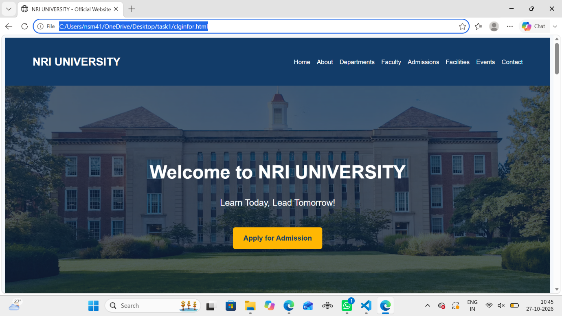

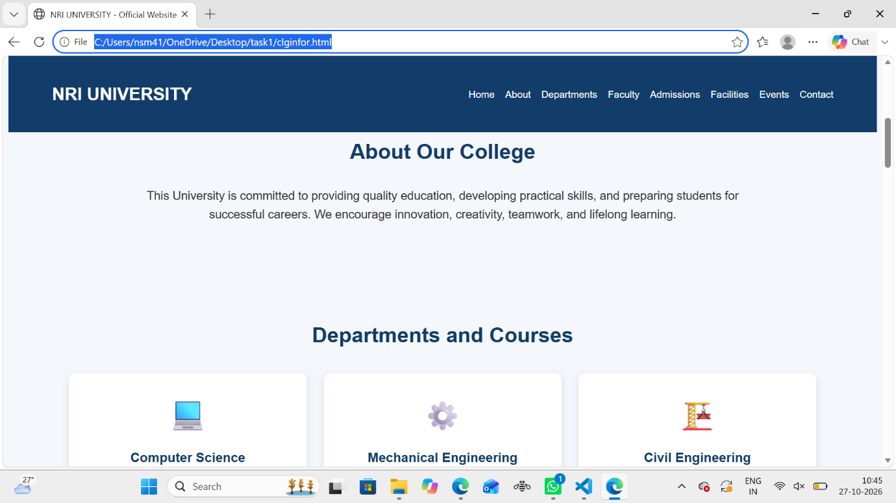

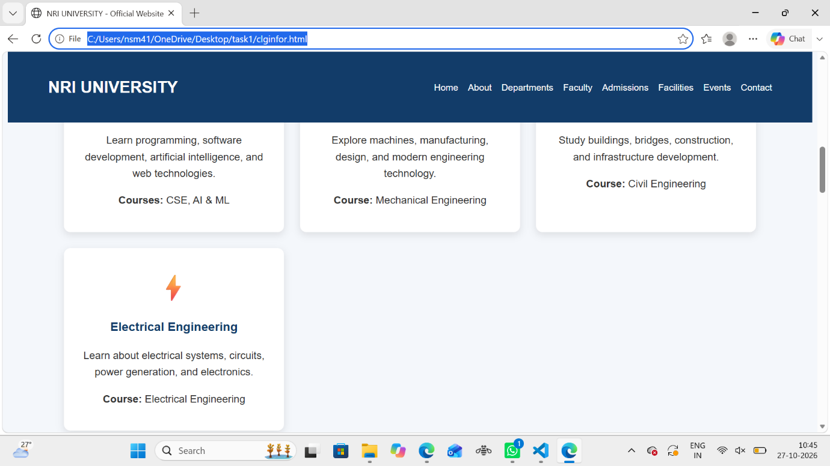

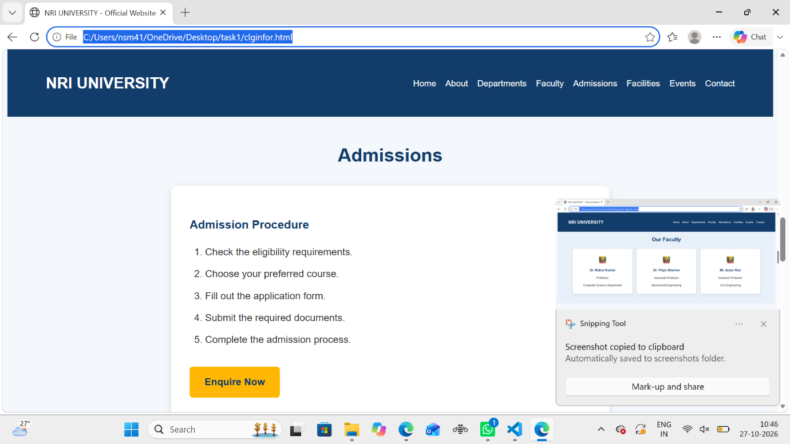

6.Conclusion
The College Information and Admissions Website was successfully designed using HTML and CSS. The website provides information about the university, departments, courses, faculty members, admission procedures, campus facilities, college events, and contact details. HTML is used to create the structure of the website, while CSS is used to improve its appearance and layout. The website includes a navigation bar, attractive banner, information cards, hover effects, and responsive design. This project helped me understand the basic concepts of web development and how to create a user-friendly website. It is a useful step toward learning advanced web technologies.

Case Study-3
Experiment: Restaurant and food website
1. Introduction
A Restaurant Website is designed to display restaurant details, food menus, prices, popular dishes, and special offers. This project, named Tasty Bites Restaurant, is developed using HTML and CSS.
The website contains a header, navigation bar, welcome section, food menu, popular dishes, special offers, and footer. It provides an attractive and user-friendly design that helps customers view different food items and their prices.
The main objective of this project is to learn the basics of web development and create an attractive restaurant website.
2. Explanation
Tasty Bites Restaurant website contains the following sections:
- Header: Displays the restaurant name and tagline.
- Navigation Bar: Provides links to the menu and popular dishes sections.
- Welcome Section: Displays a welcome message for visitors.
- Our Menu: Shows food items such as burgers, pizza, and pasta with their prices.
- Popular Dishes: Displays popular dishes such as chicken biryani, paneer tikka, and special pizza.
- Special Offers: Displays a 50% discount offer on the first order.
- Footer: Displays the restaurant's copyright information.
Technologies Used
- HTML: Used to create the structure and content of the website.
- CSS: Used to add colors, fonts, spacing, shadows, and hover effects.
Features
- Attractive restaurant design.
- Food items with prices.
- Popular dishes section.
- Special offers section.
- Hover effects on food cards.
- Responsive design for mobile devices.
3. HTML Code
Save the following code in a file named restaurant.html.
<!DOCTYPE html>
<html lang="en">
<head>
<meta charset="UTF-8">
<meta name="viewport" content="width=device-width, initial-scale=1.0">
<title>Tasty Bites Restaurant</title>
<link rel="stylesheet" href="restaurant.css">
</head>

<body>

<!-- Header -->
<header>
<h1>🍴 Tasty Bites</h1>
<p>Delicious Food, Happy Moments</p>
</header>

<!-- Navigation Bar -->
<nav>
<a href="#menu">Menu</a>
<a href="#popular">Popular Dishes</a>
<a href="#offers">Special Offers</a>
</nav>

<!-- Welcome Section -->
<div class="welcome">
<h2>Welcome to Tasty Bites!</h2>
<p>Enjoy delicious food made with love ❤️</p>
</div>

<!-- Menu Section -->
<section id="menu">
<h2>🍽️ Our Menu</h2>

<div class="item">
<h3>🍔 Burger</h3>
<p>Fresh and Tasty</p>
<p class="price">₹150</p>
</div>

<div class="item">
<h3>🍕 Pizza</h3>
<p>Delicious cheesy pizza</p>
<p class="price">₹180</p>
</div>

<div class="item">
<h3>🍝 Pasta</h3>
<p>Hot and creamy pasta</p>
<p class="price">₹120</p>
</div>
</section>

<!-- Popular Dishes -->
<section id="popular">
<h2>⭐ Popular Dishes</h2>

<div class="item">
<h3>🍗 Chicken Biryani</h3>
<p>Our special biryani</p>
<p class="price">₹250</p>
</div>

<div class="item">
<h3>🍲 Paneer Tikka</h3>
<p>Spicy and delicious</p>
<p class="price">₹280</p>
</div>

<div class="item">
<h3>🍕 Special Pizza</h3>
<p>Extra cheesy pizza</p>
<p class="price">₹220</p>
</div>
</section>

<!-- Special Offers -->
<section id="offers">
<h2>🎉 Special Offers 🎉</h2>

<div class="offer">
<h3>50% OFF 🎁</h3>
<p>Get 50% OFF on your first order!</p>
</div>
</section>

<!-- Footer -->
<footer>
<p>&copy; 2026 Tasty Bites Restaurant</p>
</footer>

</body>
</html>

4.CSS Code
Save the following code in a separate file named restaurant.css.
/* General Styling */
body {
margin: 0;
font-family: Arial, sans-serif;
background-color: #fff8f0;
color: #333;
}

/* Header */
header {
background-color: #8b0000;
color: white;
text-align: center;
padding: 25px;
}

header h1 {
font-size: 36px;
margin: 0;
}

header p {
font-size: 18px;
}

/* Navigation Bar */
nav {
background-color: #5c0000;
text-align: center;
padding: 15px;
}

nav a {
color: white;
text-decoration: none;
margin: 20px;
font-size: 18px;
font-weight: bold;
}

nav a:hover {
color: #ffcc80;
}

/* Welcome Section */
.welcome {
text-align: center;
padding: 50px;
background-color: #ffe0b2;
}

.welcome h2 {
font-size: 32px;
color: #8b0000;
}

.welcome p {
font-size: 18px;
}

/* Sections */
section {
text-align: center;
padding: 30px;
}

section h2 {
color: #8b0000;
font-size: 28px;
}

/* Food Items */
.item {
display: inline-block;
background-color: white;
width: 200px;
margin: 10px;
padding: 20px;
border-radius: 10px;
box-shadow: 0 2px 8px #ccc;
transition: transform 0.3s;
}

.item:hover {
transform: scale(1.05);
}

.item h3 {
color: #8b0000;
font-size: 20px;
}

.item p {
font-size: 16px;
}

/* Food Prices */
.price {
font-weight: bold;
color: #e65100;
font-size: 20px;
}

/* Special Offers */
.offer {
background-color: #ffcc80;
width: 300px;
max-width: 90%;
box-sizing: border-box;
margin: auto;
padding: 20px;
border-radius: 10px;
box-shadow: 0 2px 8px #ccc;
}

.offer h3 {
color: #8b0000;
font-size: 25px;
}

/* Footer */
footer {
background-color: #5c0000;
color: white;
text-align: center;
padding: 15px;
margin-top: 20px;
}

/* Responsive Design */
@media screen and (max-width: 600px) {
nav a {
display: inline-block;
margin: 8px;
font-size: 16px;
}

.welcome {
padding: 25px 10px;
}

.welcome h2 {
font-size: 26px;
}

.item {
width: 80%;
max-width: 250px;
box-sizing: border-box;
}

section {
padding: 20px 10px;
}
}
How to Run the Website
- Open Visual Studio Code or Notepad.
- Save the HTML code as restaurant.html.
- Save the CSS code as restaurant.css.
- Keep both files in the same folder.
- Open restaurant.html in Chrome or another web browser.
5.Output
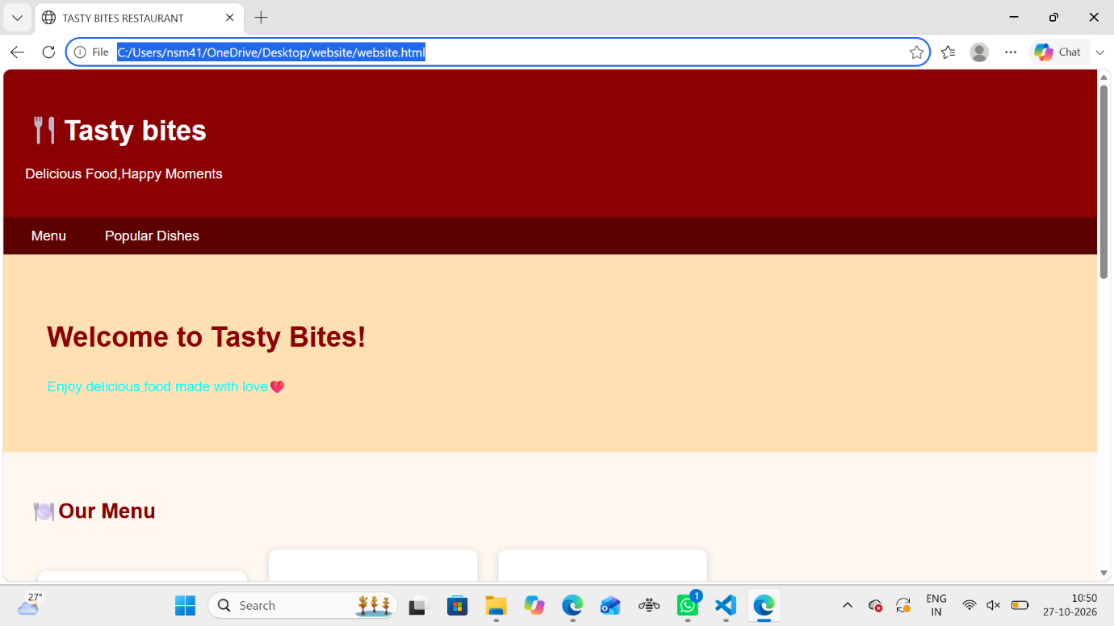

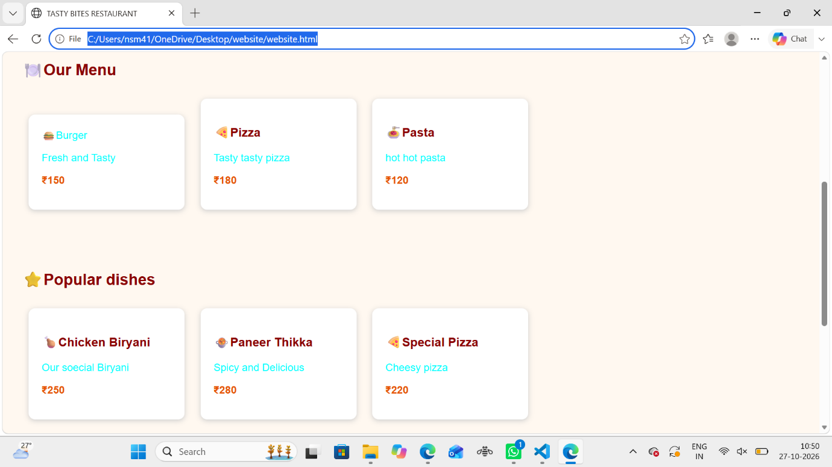

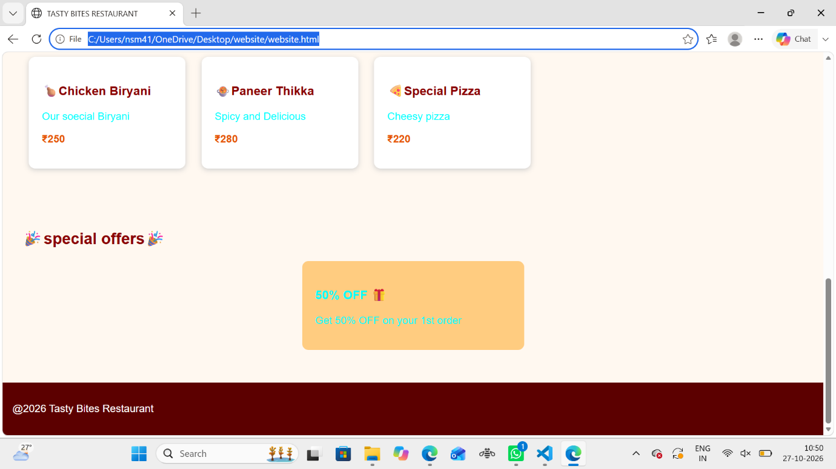
6. Conclusion
The Tasty Bites Restaurant Website was successfully designed using HTML and CSS. The website displays the restaurant name, food menu, popular dishes, prices, and special offers in an attractive layout. HTML is used to create the webpage structure, while CSS is used to improve its appearance through colors, spacing, shadows, and hover effects. The responsive design helps users view the website on different screen sizes. This project helped me understand the basic concepts of web development and learn how to design a simple, attractive, and user-friendly restaurant website.

